

**LG ATNQ21GPLE3**

**Rs. 374,800/-**

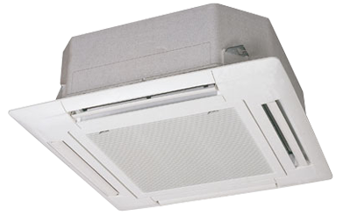

**Product Features**

* Econo Cool
* New LEV Control
* Electronic Metal Housing Box
* Self-diagnostic Function
* 15M Long Distance Airflow

**Specification**

**Type** Ceiling Cassette AC

**Cooling (Btu/h)** 37000

**Voltage (V)** 220-240

**Power Input (W)** 4300

**EER (Btu/W-h-W/W)** 5.4-2.7